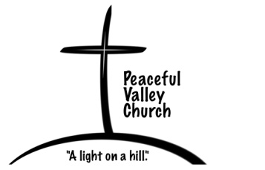
Exposed By Design
The CHURCH- Part 2

Pastor Jim Trull
Sunday, September 22, 2013

“Design is what you do when you want to express yourself.”

For we are God's fellow workers; you are God's field, God's building. By the grace God has given me, I laid a foundation as an expert builder, and someone else is building on it. But each one should be careful how he builds. For no one can lay any foundation other than the one already laid, which is Jesus Christ. 1 Corinthians 3:9-11

Review about the Church:
- The ______________________of God.
- The ______________________of God.
- The ______________________ of the church.
- Jesus _______________ the church He __________!
And I tell you that you are Peter, and on this rock I will build my church, and the gates of Hades will not overcome it.
Matthew 16:18
HAVING A STRONG FOUNDATION:
- Open your Bibles to Luke 6:46-49

- It starts with Jesus as ____________________!
"Why do you call me, 'Lord, Lord,' and do not do what I say?”
(v. 46)

- Listen _____________________ to do what the Word says.
But the man who looks intently into the perfect law that gives freedom, and continues to do this, not forgetting what he has heard, but doing it--he will be blessed in what he does.
James 1:25
- Open your Bibles to Matthew 7:21-29
Although I hope to come to you soon, I am writing you these instructions so that, if I am delayed, you will know how people ought to conduct themselves in God's household, which is the church of the living God, the pillar and foundation of the truth.
1Timothy 3:14-15
How to build a strong spiritual foundation:
- Commit to ________________ whatever Jesus says.
- Commit to ______________ what you have heard from Jesus.

Questions to consider this week:
Jesus said, “I will build my church.” What does this say about the church?
In what ways are those who hear the Word without doing what it says described? How about those who hear and do?
Jesus is either Lord of all or not Lord at all. Is Jesus Lord of your life? What does it mean to have Him as Lord?
201 Allen Road
P.O. Box 9
Elk, WA. 99009
(509) 292-8584

