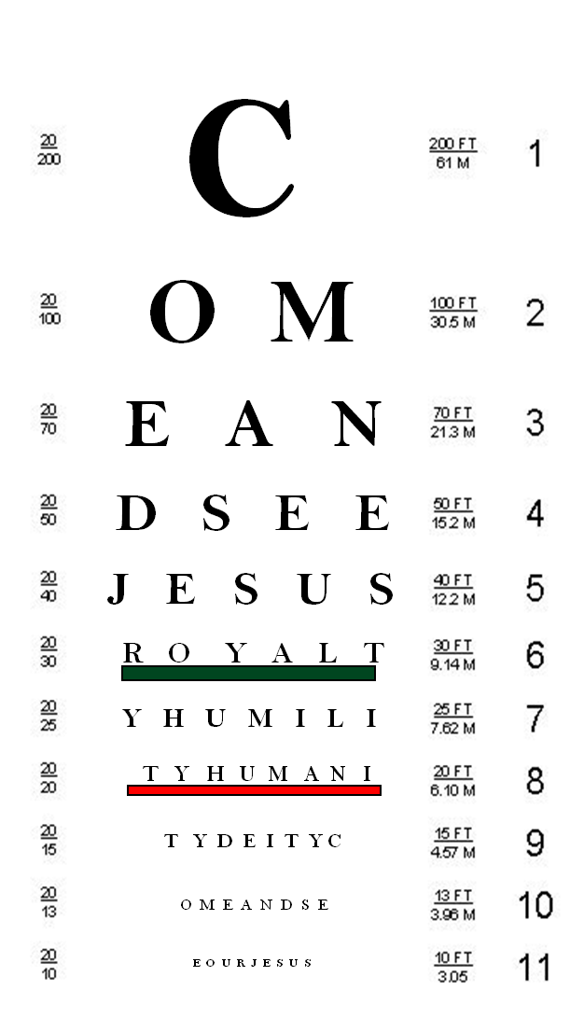
Peaceful Valley Church

Come and See…
…a glimpse of Jesus as Servant

Pastor Jim Trull- Sunday, January 13, 2013

"Everyone who calls on the name of the Lord will be saved."
Romans 10:13
- Open your Bible to Mark 10:35-45

A Glimpse of Jesus from the apostle’s perspective:
…"I tell you the truth, at the renewal of all things, when the Son of Man sits on his glorious throne, you who have followed me will also sit on twelve thrones, judging the twelve tribes of Israel. And everyone who has left houses or brothers or sisters or father or mother or children or fields for my sake will receive a hundred times as much and will inherit eternal life. But many who are first will be last, and many who are last will be first. Matthew 19:28-30

- Greatness comes by ____________________________.
Instead, whoever wants to become great among you must be your servant, Mark 10:43b
I have set you an example that you should do as I have done for you. John 13:15

- Being number one means serving _________________.
…and whoever wants to be first must be slave of all. Mark 10:44
Through him all things were made; without him nothing was made that has been made. John 1:3

- Jesus set the example of ______________________.
- Open your Bible to Philippians 2:1-8
Who, being in very nature God, did not consider equality with God something to be grasped, but made himself nothing, taking the very nature of a servant, being made in human likeness. And being found in appearance as a man, he humbled himself and became obedient to death-- even death on a cross! (vs. 6-8)

- Just a glimpse of Jesus is _____________________ enough!

Notes

201 Allen Road
P.O. Box 9
Elk, WA. 99009
(509) 292-8584

