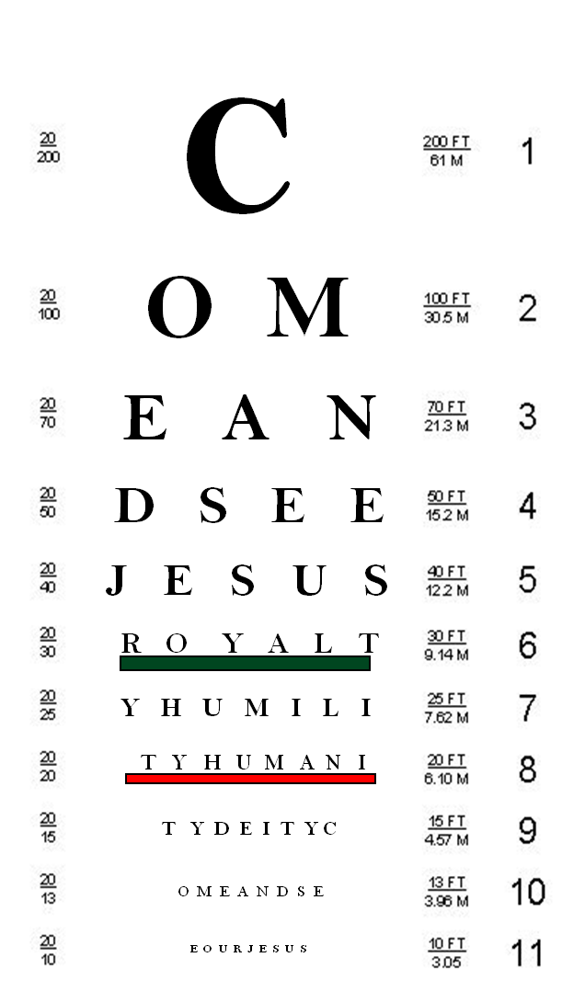
Peaceful Valley Church

Come and See…
…a glimpse of Jesus as King

Pastor Jim Trull- Sunday, January 6, 2013

- A glimpse of Jesus through the eyes of _______________________________.
But the angel said to him: "Do not be afraid, Zechariah; your prayer has been heard. Your wife Elizabeth will bear you a son, and you are to give him the name John…And he will go on before the Lord, in the spirit and power of Elijah, to turn the hearts of the fathers to their children and the disobedient to the wisdom of the righteous--to make ready a people prepared for the Lord." Luke 1:13, 17
A voice of one calling: "In the desert prepare the way for the Lord; make straight in the wilderness a highway for our God. Isaiah 40:3

- Open your Bible to Matthew 3:1-17

A Glimpse of Jesus from John’s perspective:

- His purpose was to ______________ repentance.
The whole Judean countryside and all the people of Jerusalem went out to him. Confessing their sins, they were baptized by him in the Jordan River.
Mark 1:5 (NIV)

- John saw that Jesus was ________________!

He is the one who comes after me, the thongs of whose sandals I am not worthy to untie." John 1:27

- John ___________________ Jesus as the One.
- Open your Bible to John 1:29-34
"Look, the Lamb of God, who takes away the sin of the world! Jn. 1:29b
As soon as Jesus was baptized, he went up out of the water. At that moment heaven was opened, and he saw the Spirit of God descending like a dove and lighting on him. And a voice from heaven said, "This is my Son, whom I love; with him I am well pleased." Matthew 3:16-17
- Just a glimpse of Jesus is ___________________ enough!

Notes
201 Allen Road
P.O. Box 9
Elk, WA. 99009
(509) 292-8584

